Fabien Martinez Promotion 2018

mar_b



Internship report (Tech3)





Technical officer

For

Web@cadémie, Coding Academy and Samsung Campus

I supervised a pool (like Epitech), I managed a production server and did other tasks large and small. This internship helped me a lot to improve my skills.

Start: 2016-02-29 End: 2016-08-29

Acknowledgement

I would like to express my appreciation to Sophie Viger, for giving me the opportunity to get and complete this internship. It was a great experience to work for schools as the technical officer.

I also would like to thank Mike Gilbin who trained me during one week and allowed to learn the qualities required to start my internship.

Finally, I want to thank the team who was with me the whole time and Epitech who allow me to continue this internship as a job.

Introduction

This internship report is based on my experience as the technical officer for Web@cadémie, Coding Academy and Samsung Campus. I am a third year student in Epitech, an IT educational institution and I had to find a six-month internship.

At the beginning, I postulate as a teaching assistant for Web@cadémie but Sophie Viger offer me the opportunity to become the technical officer for her schools.

As a technical officer I had a lot of tasks during these months, like help students to fix their computers, create new web applications. I worked with some schools like Epitech and Epita. It was a great internship who helped me to learn a lot and who helped me to improve my skills. It was difficult to organize my time to work and realize all my tasks.

This document will explain how to continue my job and why I want to keep it and continue to do with the team.

Table of contents

Part one 2

Understand the job and tasks 2

Discover Web@cadémie, Coding Academy and Samsung Campus 2

1. Presentation 2

2. Our premises 3

3. Team 4

4. Map 5

Discover your future tasks and projects 6

1. Manage pools 6

2. Administer servers 8

3. Help students 9

4. Organize and go to events 9

5. Create and improve tools and web applications 10

6. Support staff to recruit new assistants or students and mark defenses 11

7. Go to meetings with the team 11

Conclusion 11

Part Two 12

Improve our pools 12

Conclusion 14

Part one

Understand the job and tasks



# Discover Web@cadémie, Coding Academy and Samsung Campus

## Presentation

There are three schools who need a technical officer

### Web@cadémie

Since 2010, the Web@cademie offers a free two-year training program in web development in Paris and in Lyon to young people aged 18 to 25 who do not have the Baccalauréat (A levels).

The training program lasts 24 months and is divided in the following manner:

- 12 months of teaching within the Epitech Campus

- 12 months of professional training contract

The Web@cademie education is delivered by Epitech, which has solidified its reputation as a leading educational institution transforming a passion for computer science into expertise.

Epitech’s innovative model is built upon three qualities that are increasingly required in the workplace: adaptability, self-development and a sense of project management. It is a modern model built on experience, oriented towards action and project development.

The alumni network consists of 101 alumni, who either work as web developers or pursue their education at ETNA, which offers 3-year courses for software architects, application developers and network and security systems architects.

### Coding Academy

The Coding Academy is an innovative school who offers for €4900 an intensive training program in web development.

Every session lasts 5 months and allow people aged 20 to 45. They must have at least an associate’s degree and be ready for an 9am to 9pm work every day (except week-end).

Like the Web@cademie, education is delivered by Epitech and will allow learners to “learn how to learn”.

Every week, a speaker will come and present a new subject like web security, new technologies, etc.

The Coding Academy is available in Paris and will be available in other countries like Munich, Barcelona and London.

### Samsung Campus

The Samsung Campus is like the Web@cademie, it’s a free two-year training program in web development near Paris (Saint-Ouen) to young people aged 18 to 25 who do not have the Baccalauréat.

Samsung created this school with Epitech and Zup2Co.Samsung provides stuff like Pc and premises.

## Our premises

Our premises are based in Epitech, Paris, Lyon and in the Samsung Campus.

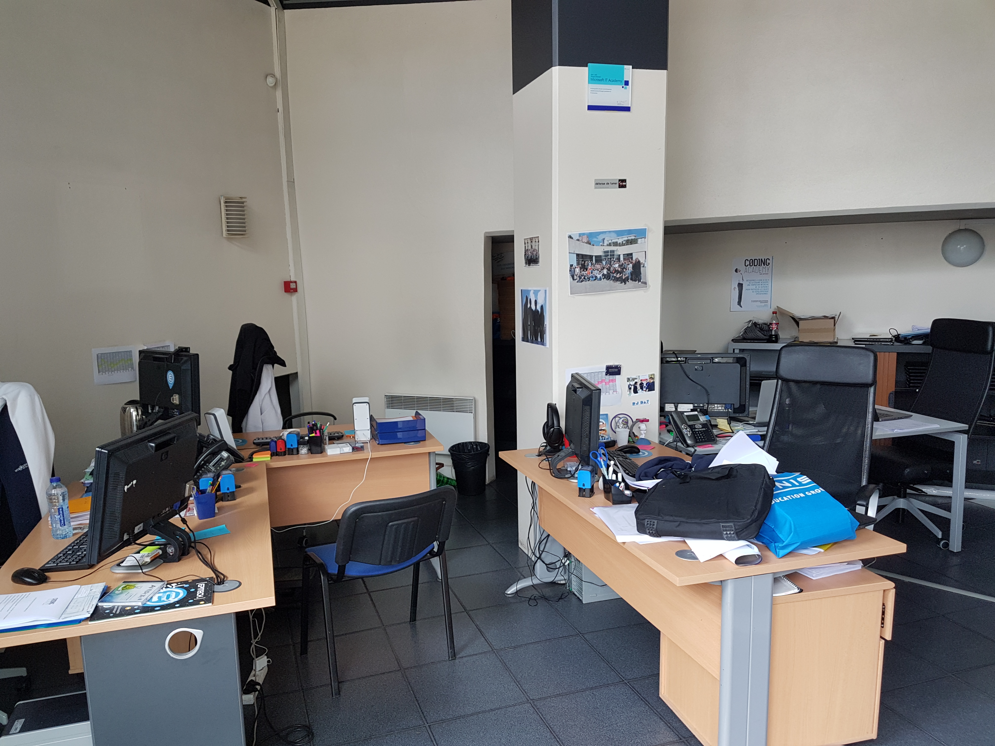

*Figure 1 – Staff’s premises in Epitech Paris*

In these premises there is a lot of stuff like laptops, students’ documents, etc.

## Team

We are 6 in Epitech Paris, 1 in Epitech Lyon and 1 in Samsung Campus. There are some interns too.

Every 6 months we hire new assistants for schools, they will help us during pools and they will help students. We are looking for two new heads teacher for the Coding Academy and the Samsung Campus.

Each teacher officer leads promotions with 20 or more students so they can help them easier, without any trouble. They do anything to improve every promotion.

The partnership officer is here to find new societies and help students to find a professional training contract.

The administrative assistant helps students in their steps to fill any document. She is versatile and she has to go in Saint-Ouen every week to help them.

The technical officer does every technical tasks like administrate servers, manage pools, correct and create new tests, etc.

Assistants are here to help students during their projects. They can give some lectures and create new subjects.

## Map

We are based in France but the next year will allow us to grow up and we will add other school in France and other countries like Spain and Germany.

*Figure 2 – Staff’s premises in Epitech Paris*

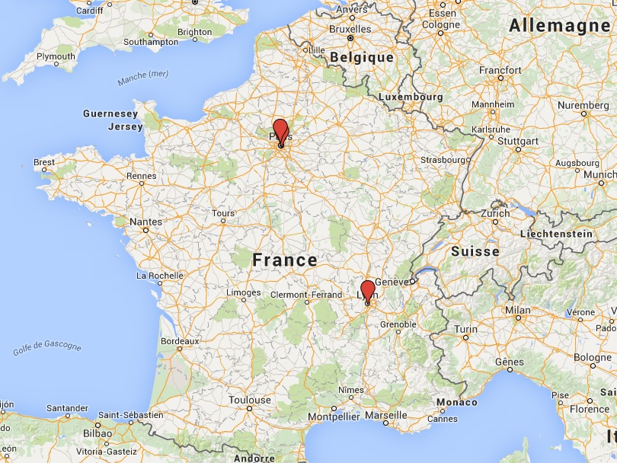

There are 3 points for the moment, but it will grow up in 2017, April with 12 new schools.

# Discover your future tasks and projects

As a DevOps (a developer and administrator system), there are a lot of tasks like fix and secure servers, create new content for students, go to events etc.

## Manage pools

As the school **42**, to integrate Web@cademie or Samsung Campus everyone must success a pool.

What is a pool? A pool is an intensive program where students will do a lot of exercises every day. A new notion will be inculcated and students will need to work harder every day. They will work **twelve** hours a day, **seven** days a week for **three** weeks. During these weeks they will learn PHP.

You must prepare the pool and check everything.

### Schedule the pool

The first step is to schedule the pool. There are some conditions required. Indeed, you must check with Epitech and Epita about their pools to add your own pool because we share same rooms.

We have to customize an OS (Operating System) and use it during pools. It will wrap a lot of tools to help students to commit their work, connect on internet, do exams, etc.

After these steps, you must talk with Nicolas Geniteau. He will help you to set computes in rooms used for the pool. You have to send him the fresh customized OS and he will dispatch it everywhere.

Last session got around 50 people and the OS had some problems. It was hard to fix but you will only need to create little patch to update it.

*Figure 3 – First day of Web@cademie’s pool (2016)*

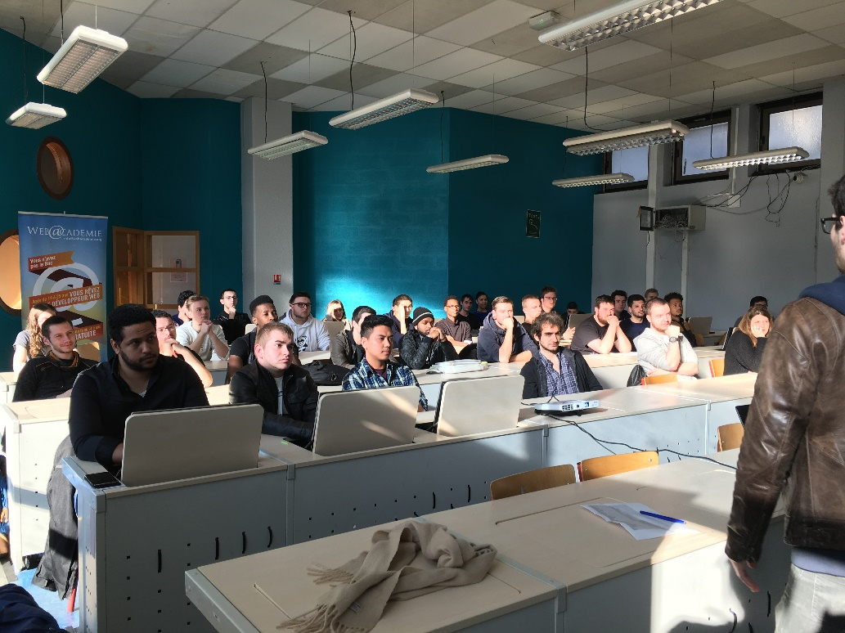

### Check tools before starting

Days will be corrected by an automatic program called **pangolinette**. It’s a php program created for and by our schools. There is a web interface which allow us to schedule correction like Epitech does. You can choose your school, which project and students need to be correct and the date.

You must check every exercises too and check the correction too.

*Figure 4 – web application used to schedule corrections*

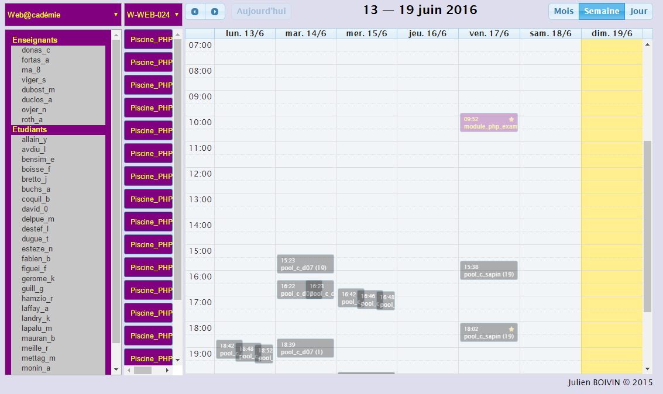

### Supervise the pool

Every day will be different, you will need to patch every issue as soon as possible. To simplify students’ life, we added some automatics programs. It might be a mistake because they can’t learn some features like *how to commit your work* etc. If any error occurs with these programs they will not be able to push their work. You will need to fix these issues. Fortunately, you can update your customized OS easily and you can ask Nicolas Geniteau to dispatch the new version. Students will need to reboot to get the update.

A background program (written in bash) allows you to help without requiring a reboot. With this program you can apply update and play some jokes like playing a song on all computers, change their background. You can send them messages like “*Don’t forget your exam tomorrow*” to warn them for example.

## Administer servers

Because you are a system administrator too, you are responsible for the upkeep, configuration and reliable operation of schools’ servers. There are two servers, one used for the production and another to tests new web applications and programs.

You will need to secure these servers to prevent any intrusion. We already had some issues before. For example, we used our production server as a mail server and someone hacked it to send spam messages. We fixed it as soon as possible by disabling our mail server.

We added SSL certificates recently, helping to ensure a secured connection through our web applications. Indeed, these certificates allow to use **https** instead of **http**. You will need to check their validity every 90 days.

You will need to remove the former technical officer from authorization list and change every password.

You have not physical access on the production server, it’s a virtual machine hosted by The **Bocal**, an entity which manages infrastructure in our schools and in Epitech too. If you have any issue you will need to create a ticket in their intranet and wait for them.

All of your web applications must be deployed first on the development server then in production.

*Figure 5 – Bocal intranet used to create ticket if you have any issue or request*

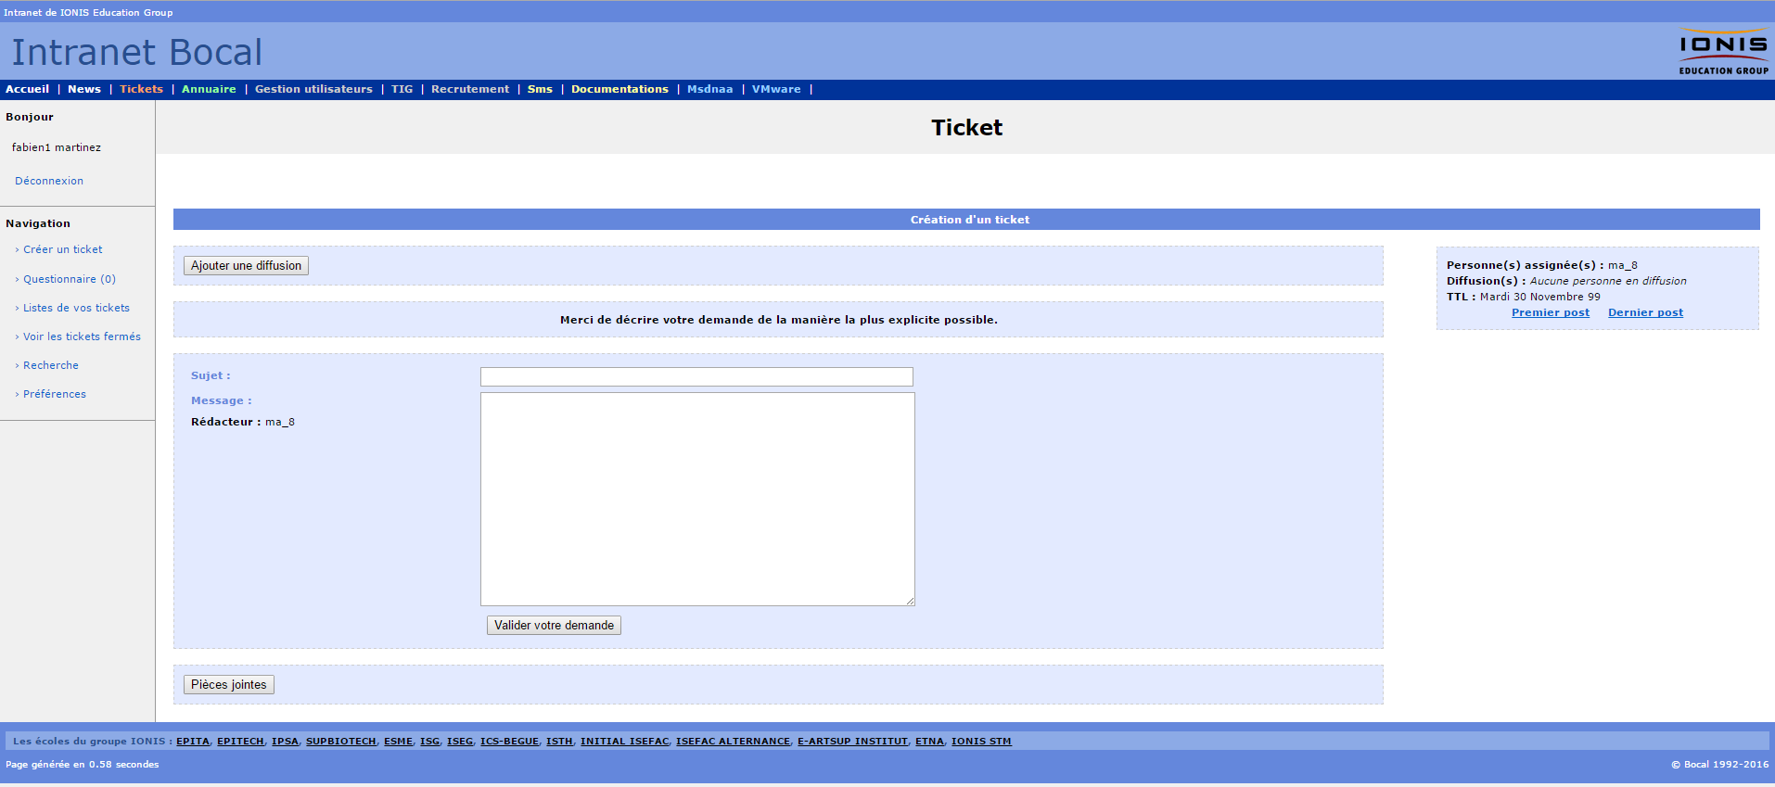

## Help students

You will need to help students during pool but after it too. Indeed, they will need your help to set-up their computer during the year. While in school they will have some issues and you will need to fix them. Be prepared about it.

You have to know how to set up a new internet connection, how to add a new key to allow them to commit their work and how to install new program such as MYSQL and PHP. These issues are the most common and you must be able to fix them quickly.

## Organize and go to events

Every year a lot of events occur such as hackathons or meetings. You might be asked to organize some events and go to them with some students to escort them. To organize an event, you must found a room (you can ask the partnership officer to help you), ask students with a straw poll and prepare some computers.

There is a module called “hour of code” where 4-5 students will help schoolgirls to learn the code during an hour. You must prepare laptops (around 30) every time and check them after sessions.

Hackathons allow students to create new applications in a week-end with other students / officer project. You must encourage and help them. Indeed, you could be asked to resolve any issue.

*Figure 6 – Hackathon around immigrants – 3 Web@cademie’s students*

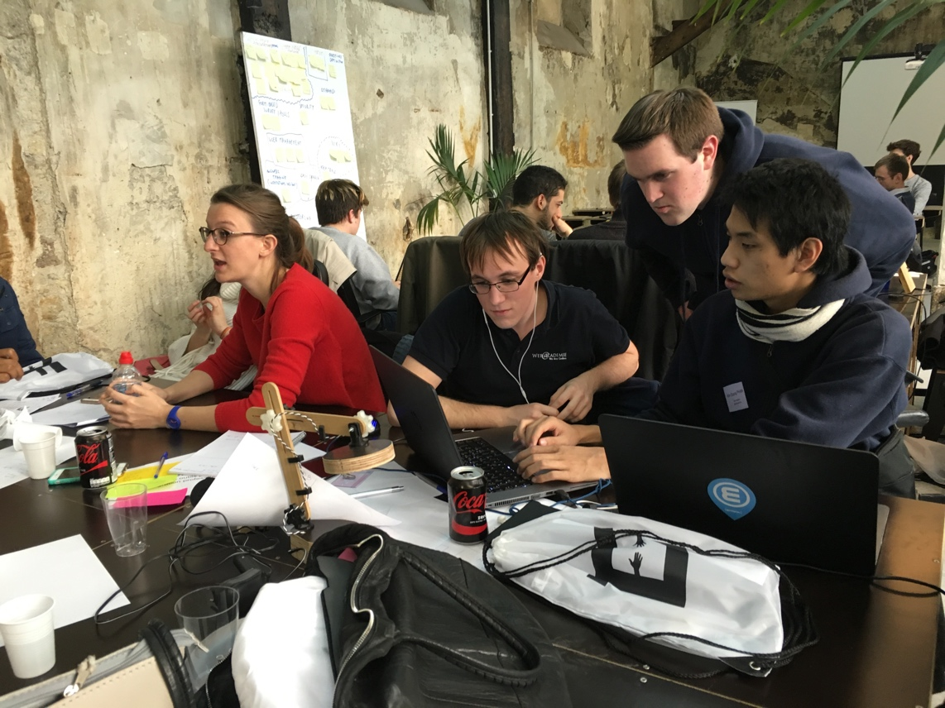

## Create and improve tools and web applications

There are a lot of web applications already such as a web interface for the pangolinette, a tool used to check students’ presence, web applications to hire students, etc.

These programs must be updated and improved:

* Pangolinette (PHP):
  + Refactor code and improve it to allow to add new modules easily
  + Refactor database
* CV – Web application (PHP - angularjs):
  + Update the web application and spread it around all schools, not only Web@cademie Paris
* CRM (Customer Relationship Management – tool used to interact with customers) (PHP):
  + Refactor web application (currently one web application per school)
  + Change design
  + Allow more interactions such as add new staff member, update rights etc.
  + Regroup CRMs into one
* Presence tool – Used to check students’ presence in their 2nd year (MEAN):
  + Create an admin panel to administrate it
  + Refactor code to add new schools / years easily
* Etc. There are a lot of other tools / web applications to create or update

Every year we need to create new applications to help our team or students such as a program which will check if the students cheated or not (we did it this year).

*Figure 7 – Current CRM application, one by school / city*

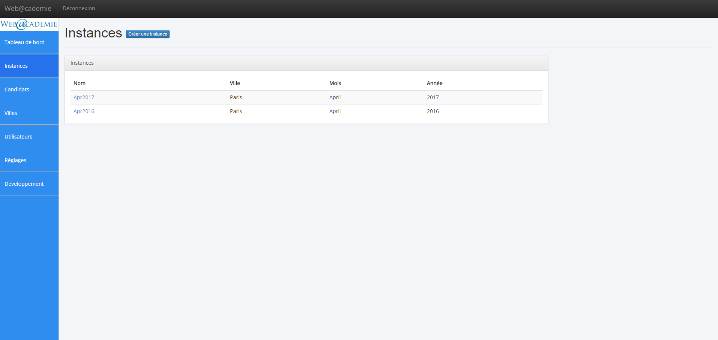

## Support staff to recruit new assistants or students and mark defenses

We often have to recruit new assistants because we take trainees (6 months).

You will be with another staff member during interviews and will you ask technical questions about PHP especially. These interviews last 30 minutes and you will prepare a technical test to check their level.

As sais earlier, you will need to prepare a technical test and schedule it on intra.epitech.eu. This will be a PHP exam, so you must create exercises (around 10) and create the correction.

After these steps, you will send an answer about his candidacy.

You may need to help teacher officers to mark students for regular defense but not only. You may need to mark students oral defense as jury with their training master. You must be objective and help them to improve their skills.

## Go to meetings with the team

You will have to organize and sit in meetings with the team every week. Indeed, you will assist to web@cademie’s meeting every week and you will talk about technical issue (rarely).

Every two weeks you will organize a meeting with the teacher officers Odin, Mathias and Thomas (Web@cademie Paris / Lyon and Samsung Campus) and talk about subjects such as what module / language can we add in these schools.

Sometimes you must assist to a big meeting with everyone and talk about full of different things like how is the team etc.

# Conclusion

You will have a lot of different tasks such as organize meetings, create new web application, help students or administrate servers. You will become a **devops**, a developer and a system administrator.

You will learn a lot and quickly, you must be prepared.

Part Two

Improve our pools







Fabien MARTINEZ

14, rue Carnot – Villejuif – 94800 - France

[fabien1.martinez@epitech.eu](mailto:fabien1.martinez@epitech.eu)

Web apps and coding

14/16 rue Voltaire

94276 Kremlin Bicêtre – France

June, 26th, 2016

**Subject: Create a new pool without issue**

Dear M. Viger,

During this internship I worked as technical officer in your team and I learnt a lot about your schools and issues. These six months have helped me to interact with everyone, students and staff members. Last pool was not good even if I tried to avoid issues such as cheating, connection and correction difficulties. We already talked about creating a new pool.

I would like to meet an exciting challenge by creating a new pool and managing it. My objectives for this project are to amend new exercises with new notion, it will reduce cheating because students will not be able to find php snippets on the web (github.com). I am enthusiastic to update tests subjects because I want to show total involvement in this project.

During my internship I talked with students that helped me to increase my interpersonal skills. With the last pool I communicated with people to try to improve the pool quality. I learnt a lot with them and I’m now confident enough to create a new pool.

I am highly organized individual, sociable and confident. That’s why I would like to stay with you to show you how I am strongly motivated about this exciting project.

I look forward to hearing from you.

Yours Faithfully,

Fabien MARTINEZ

Conclusion